Marker Plagiarism Check Acknowledgement Form

I, ___Munish Kumar__________ (name of marker), _____M2090099_______ (PI Number) declare that I have reviewed all Turnitin plagiarism reports corresponding to the candidates who submitted answer scripts in the following assessments marked by me in __Jul 2021___ semester (Month/Year).

Course Code | Assessment Inspected  (TMA/GBA/ECA/Capstone Final Report)* | Number of Reports Marked in Assessment | Number of Reports Suspected of Plagiarism
ANL488 | Capstone Project Proposal | 3 | 0
Total Number of Reports Inspected |  | 3 | 0

*You may expand the table if you have more inputs. This form should contain the plagiarism reports of all assessments you have marked in a particular programme.

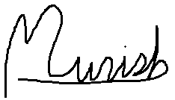
____________________________ ____20 Aug 21_____________
Signature of Marker Date

